Insert your name, centre number and candidate number into the header above.
Save this evidence document as evidence_ followed by your centre number_ candidate number. For example: evidence_ zz999_9999.doc
Screenshots or program listings must be copied into appropriate cells in the following tables.
Examiners must be able to read the contents including any screenshots without the use of a magnifying glass. Answers that are not readable or missing will not be awarded any marks.
Save this evidence document at regular intervals, for example, every 10 minutes.
Question 1
Part 1(a)
{Copy and paste program code listing for question 1(a) here}

global HeadPointer
global TailPointer
global Queue # DECLARE Queue: ARRAY[0:49] OF INTEGER

#main
Queue=[-1 for _ in range(50)]
HeadPointer=-1
TailPointer=-1

Part 1(b)
{Copy and paste program code listing for question 1(b) here}

def Enqueue(Num):
global HeadPointer
global TailPointer
global Queue

if TailPointer>=len(Queue)-1:
return False
if TailPointer==-1:
HeadPointer=0

TailPointer+=1
Queue[TailPointer]=Num
return True

Part 1(c)
{Copy and paste program code listing for question 1(c) here}

def Dequeue():
global HeadPointer
global TailPointer
global Queue

if HeadPointer==-1 or HeadPointer>TailPointer:
return -1

HeadPointer+=1
return Queue[HeadPointer-1]

Part 1(d)
{Copy and paste program code listing for question 1(d) here}

def CreateQueue():
try:
f=open("QueueData.txt",'r')
for line in f:
if not Enqueue(int(line.strip())):
print("Queue full")
f.close()
except IOError:
print("File not found.")

Part 1(e)(i)
{Copy and paste program code listing for question 1(e)(i) here}

CreateQueue()
Sum=0
for i in range(len(Queue)):
Temp=Dequeue()
if Temp!=-1:
Sum+=Temp
print(f"Total: {Sum}")

Part 1(e)(ii)
{Copy and paste screenshot for question 1(e)(ii) here}

Question 2
Part 2(a)
{Copy and paste program code listing for question 2(a) here}

#main
DataArray=[0,3,4,56,67,44,43,32,31,345,45,6,54,1]

Part 2(b)
{Copy and paste program code listing for question 2(b) here}

def InsertionSort(ArrayInt):
for i in range(1,len(ArrayInt)):
HolePosition=i
Data=ArrayInt[i]
while HolePosition>0 and ArrayInt[HolePosition-1]>Data:
ArrayInt[HolePosition]=ArrayInt[HolePosition-1]
HolePosition-=1
ArrayInt[HolePosition]=Data

return ArrayInt

Part 2(c)
{Copy and paste program code listing for question 2(c) here}

def OutputArray(ArrayInt):
for Item in ArrayInt:
print(Item, end=" ")
print("")

Part 2(d)(i)
{Copy and paste program code listing for question 2(d)(i) here}

OutputArray(DataArray)
DataArray=InsertionSort(DataArray)
OutputArray(DataArray)

Part 2(d)(ii)
{Copy and paste screenshot for question 2(d)(ii) here}

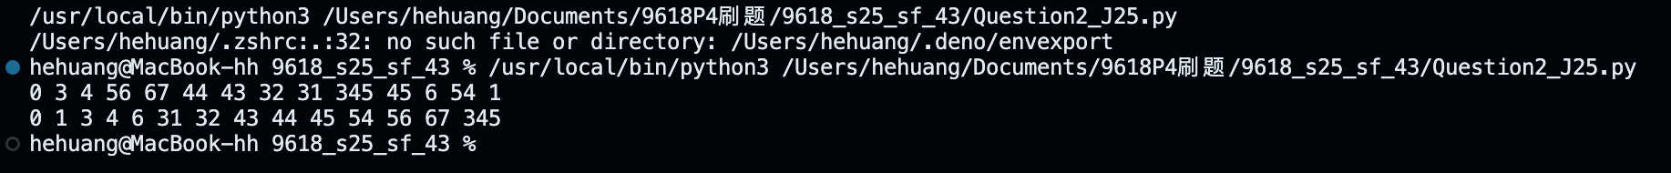

Part 2(e)
{Copy and paste program code listing for question 2(e) here}

def Search(DataArray,ItemToFind):
Lower=0
Upper=len(DataArray)-1

while Upper>=Lower:
Mid=(Lower+Upper)//2
if DataArray[Mid]==ItemToFind:
return Mid
elif DataArray[Mid]>ItemToFind:
Upper=Mid-1
elif DataArray[Mid]<ItemToFind:
Lower=Mid+1

return -1

Part 2(f)(i)
{Copy and paste program code listing for question 2(f)(i) here}

if Search(DataArray,0)==-1: print("0 was not found")
else: print(f"0 is in the index {Search(DataArray,0)}")
if Search(DataArray,345)==-1: print("345 was not found")
else: print(f"345 is in the index {Search(DataArray,345)}")
if Search(DataArray,67)==-1: print("67 was not found")
else: print(f"67 is in the index {Search(DataArray,67)}")
if Search(DataArray,2)==-1: print("2 was not found")
else: print(f"2 is in the index {Search(DataArray,2)}")

Part 2(f)(ii)
{Copy and paste screenshot for question 2(f)(ii) here}

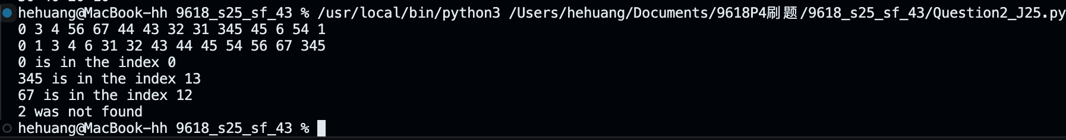

Question 3
Part 3(a)(i)
{Copy and paste program code listing for question 3(a)(i) here}

class Node:
def __init__(self,td):
self.__TheData=td # PRIVATE TheData: INTEGER
self.__NextNode=None # PRIVATE NextNode: Node

Part 3(a)(ii)
{Copy and paste program code listing for question 3(a)(ii) here}

def GetData(self): return self.__TheData
def GetNextNode(self): return self.__NextNode

Part 3(a)(iii)
{Copy and paste program code listing for question 3(a)(iii) here}

def SetNextNode(self,Next): self.__NextNode=Next

Part 3(b)(i)
{Copy and paste program code listing for question 3(b)(i) here}

class LinkedList:
def __init__(self):
self.__HeadNode=None # PRIVATE HeadNode: Node

Part 3(b)(ii)
{Copy and paste program code listing for question 3(b)(ii) here}

def InsertNode(self,Num):
NewNode=Node(Num)
NewNode.SetNextNode(self.__HeadNode)
self.__HeadNode=NewNode

Part 3(b)(iii)
{Copy and paste program code listing for question 3(b)(iii) here}

def Traverse(self):
ResultString=""
CurrentNode=self.__HeadNode
while CurrentNode is not None:
ResultString+=str(CurrentNode.GetData())+" "
CurrentNode=CurrentNode.GetNextNode()

return ResultString[0:len(ResultString)]

Part 3(b)(iv)
{Copy and paste program code listing for question 3(b)(iv) here}

def RemoveNode(self,Num):
if self.__HeadNode is None:
return False

if self.__HeadNode.GetData()==Num:
self.__HeadNode=self.__HeadNode.GetNextNode()
return True
else:
CurrentNode=self.__HeadNode
LastNode=self.__HeadNode
while CurrentNode is not None:
if CurrentNode.GetData()==Num:
LastNode.SetNextNode(CurrentNode.GetNextNode())
return True
else:
LastNode=CurrentNode
CurrentNode=CurrentNode.GetNextNode()
return False

Part 3(c)(i)
{Copy and paste program code listing for question 3(c)(i) here}

#main
LList=LinkedList()
LList.InsertNode(10)
LList.InsertNode(20)
LList.InsertNode(30)
LList.InsertNode(40)
LList.InsertNode(50)

print(LList.Traverse())
LList.RemoveNode(30)
print(LList.Traverse())

Part 3(c)(ii)
{Copy and paste screenshot for question 3(c)(ii) here}

